**Experiment: Common Gate Amplifier**

**Aim:**

To implement a common gate amplifier of gain 10 and analyze its transient and ac characteristics.

**Tool Used:**

LTspice

**Theory:**

The common-gate (CG) amplifier for MOSFET is the analogue of the common base amplifier for BJT. Its popularity arises from its lower noise and ease of impedance matching.

For a Level 3 NMOS let’s assume

VGS = 0.6V

VT = 0.4V

VDD = 1.8V

Kn = 120µA/V2 ,

Which gives a value of (W/L) = 416 for 1mA ID.

Also, for these values gm is attained as 10mΩ-1, therefore for gain 10, RD is taken as 1KΩ.

The value of VDS should be maintained above (VGS - VT = 0.6 - 0.4 = 0.2V) for the transistor to stay in saturation region.

As W/L is 416, the width is taken as 416µm and the length is taken as 1µm.

**Circuit Schematic:**

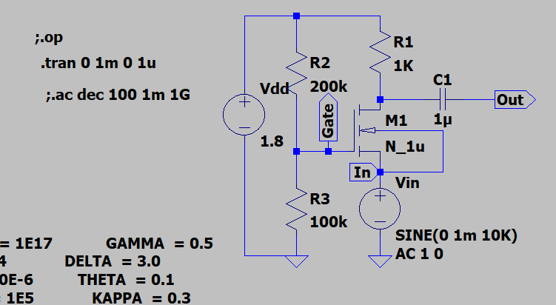

**Output Waveforms:**

DC operating Point

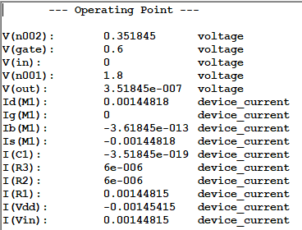

Transient characteristics

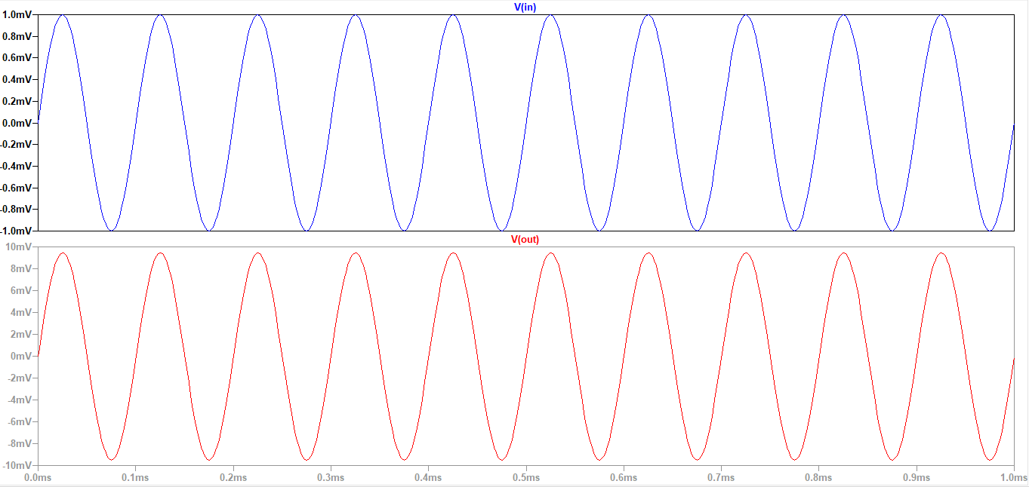

AC Analysis

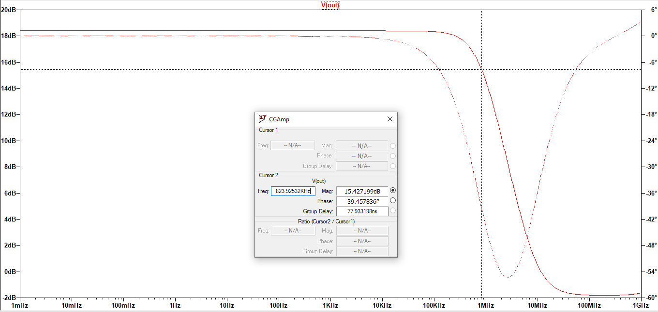

**Result:**

The circuit is designed for a gain of 10 and the output is verified to be correct. The transient and AC characteristics are visualized.

Bandwidth, FC = 823KHz.